Georgia Gymnastics Academy and the GGA Parents Club
Proudly announces
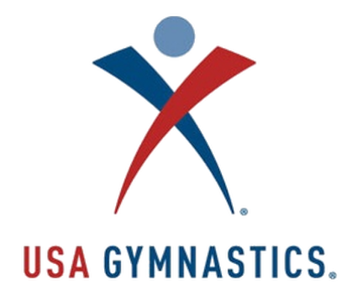
Date: March 27-29, 2020

Where: Dacula High School
123 Broad Street
Dacula, GA 30019

Levels: USAG 6/9/10

Equipment: AAI Elite X-Wide Bars
AAI Reflex Beam, Spring Floor

Entry Fees: USAG 6/9/10 ………….... $85
Team Fee………………….. $60
Late Fee: $50 per gymnast after March 9, 2020

Meet Deadline: March 9, 2020
Qualification/Refund Deadline: March 16, 2020
We are committed to expenses and will be unable to refund any entry fees for any reason, regardless of circumstance after 3/16/2020.

Awards: Individual & All-Around…50% +1

Admission: Adult………………………….$10
Credit Cards will be accepted Admission and Concessions
Child 12 & Under……………..$5
Seniors (over 60) ………………$5
5 & Under…………………… Free
Weekend Pass………………..$15
Questions: http://www.ggaparentsclub.com...click Meets
For Forms & Rotation Schedules: www.ggaparentsclub.com...click Meets

Make Checks Payable to GGA Parents Club and Return Entry Form to:
Georgia Gymnastics Academy, Inc
Attn: Shawn Robinson
98 Patterson Road
Lawrenceville, GA 30044

